Промежуточная аттестация по английскому языку 1 полугодие
9 класс (УМК «Spotlight»)

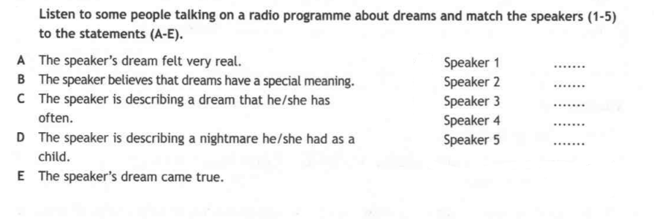
TASK 1. LISTENING
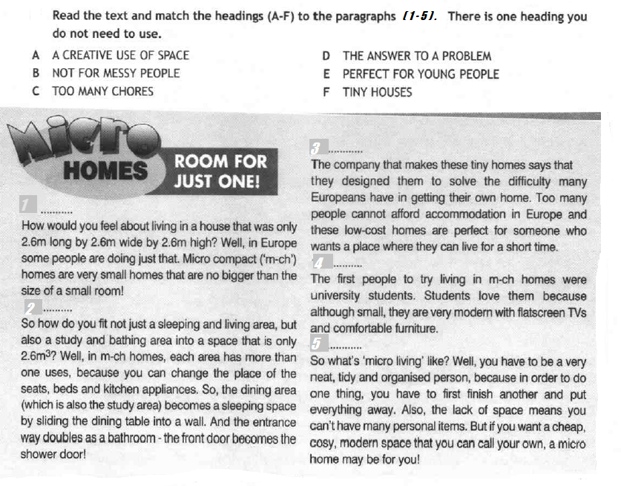
TASK 2. READING

TASK 3. VOCABULARY AND GRAMMAR
- Fill in the write word.

pitch | human | raise | mythical | mopped | contest | glimpse | mind | hose | street

- Why don’t you take part in the sculpture ____________? I’m sure you’ll be the winner.
- Astronauts who work on the ISS use a vacuum___________ to wash with.
- Eric has a brilliant __________; he’s sure to become a famous scientist one day.
- Take off your shoes before going into the kitchen. Mum has just _________ the floor.
- This couldn’t be a _______ print; it’s far too wide and half a metre long!
- Children were thrilled to see Disney floats at this year’s colourful __________ parade.
- Peter and Frank play football at their local football __________ every day.
- The strange creature disappeared before we managed to catch a ___________ of it.
- ________ creatures such as giants, dragons and sea monsters often appear in Northern European folklore.
- Cake sales are great way to ________ money for charities, as they are inexpensive and easy to organize.

- Choose the correct item.

- Why don’t we leave a bit later tomorrow? I can’t stand (wake / to wake / waking) up early!
- While Lisa (read / was reading / had been reading) a book, her brother (was listening / listened / had been listening) to music.
- Jane (think / is thinking / thinks) about taking part in the Mardi Gras parade next week.
- Ann (gasp / gasped / had gasped) in horror when she saw the ghostly figure.
- The children (have played / have been playing / play) in the garden all morning; that’s why their clothes are dirty.
- Jill made her brother (to promise / promising / promise) never to take her personal things again.
- Sarah (painting / had been paining / had painted) for three years before she sold her first painting.
- Jonh wants (become / to become / becoming) an astronaut when he grows up.
- The Prague Spring International Music Festival (starts / is starting / has started) in the middle of May and lasts for about two weeks.
- Jessica ___already___ (decided / has decided / have decided) what to wear at tonight’s school prom.

- Write the correct form of the capitalized words.

Piranhas are South American fish. There are lots of scary stories about them. Most people think that piranhas are very __________________(DANGER) creatures.
However, a __________________ (SCIENCE) from St. Andrews University, Anne Magurran, has recently announced that to call piranhas cruel killers is not fair.They __________________ (USUAL) eat fish, plants and insects.According to Professor Anne Magurran, piranhas attack people and animals only when they want to defend themselves. However, most travellers strongly disagree with this point of view.They recommend keeping away from the water where piranhas live. When the fish attack in groups, it is practically __________________ (POSSIBLE) to survive.Whatever your opinion of piranhas, this is a __________________ (USE) piece of advice one should follow.

Рекомендуемые критерии оценивания:
Раздел 1: аудирование | Макс.балл – 5 | Итого:  Максимальный балл за работу - 35
Раздел 2: чтение | Макс.балл – 5 | Итого:  Максимальный балл за работу - 35
Раздел 3: Лексика и грамматика | Макс.балл – 25 | Итого:  Максимальный балл за работу - 35

Оценка «5» отлично | 31-35 баллов
Оценка «4» хорошо | 26-30 баллов
Оценка «3» удовлетворительно | 18-25 баллов

